1. Create VPC with 2 private and 2 public subnets.

Go to *AWS console* search for **VPC** and select **Create VPC**,Then select **2** on **Availability zone** to create *2 public* and *2 private* subnets

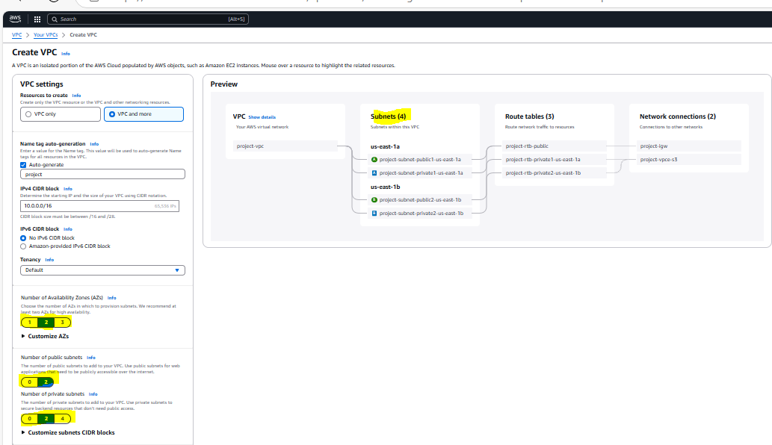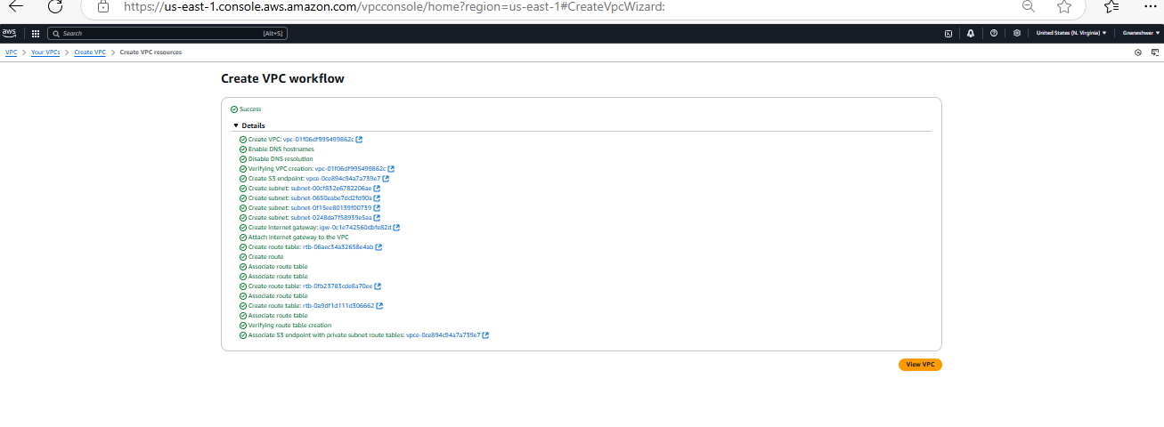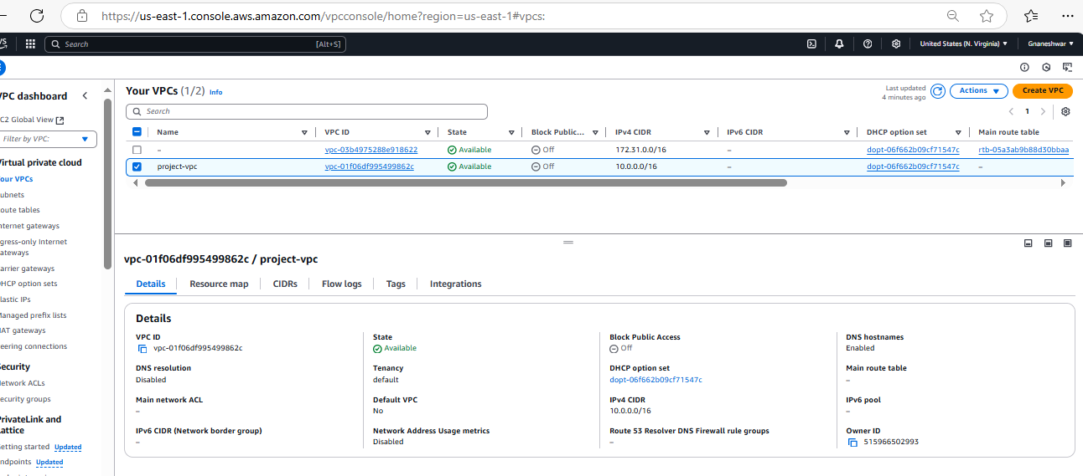

1. Enable DNS Hostname in VPC

While creating a VPC click on box **Enable DNS hostnames** under **DNS options** to enable *DNS hostnames*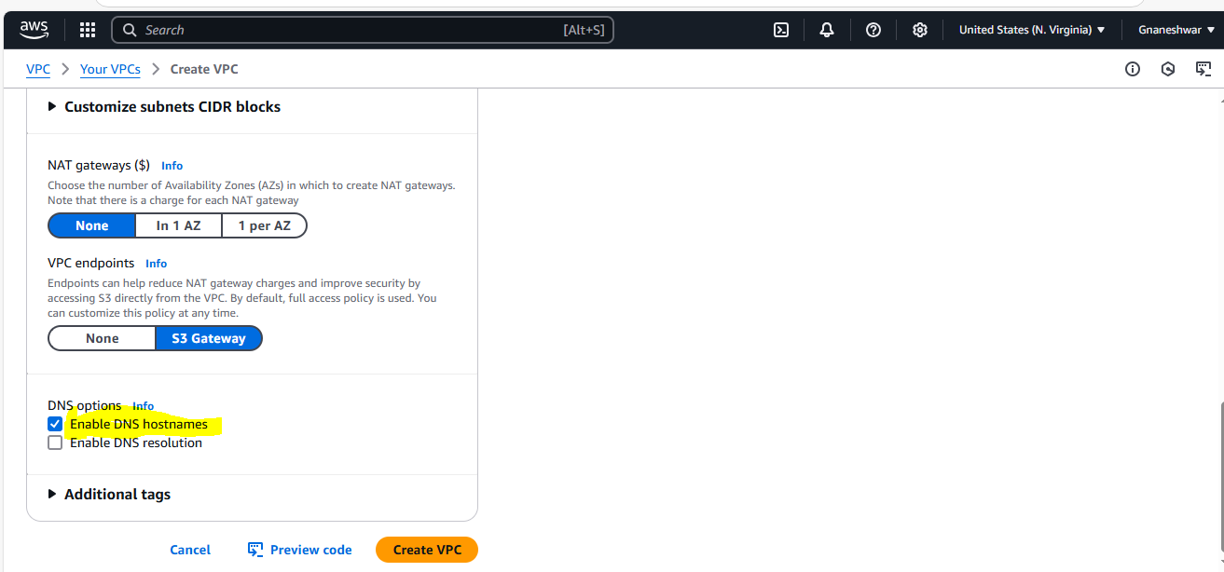

1. Enable Auto Assign Public ip in 2 public subnets

**Select public subnet** which you want to edit and open the link

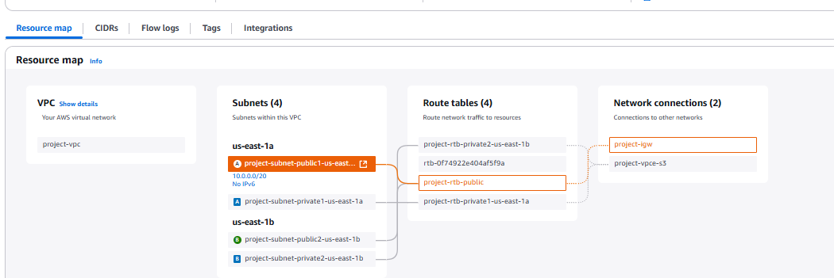

Then it will open new Tab with all Subnet details.Next select **edit subnet setting**s option under **Actions**

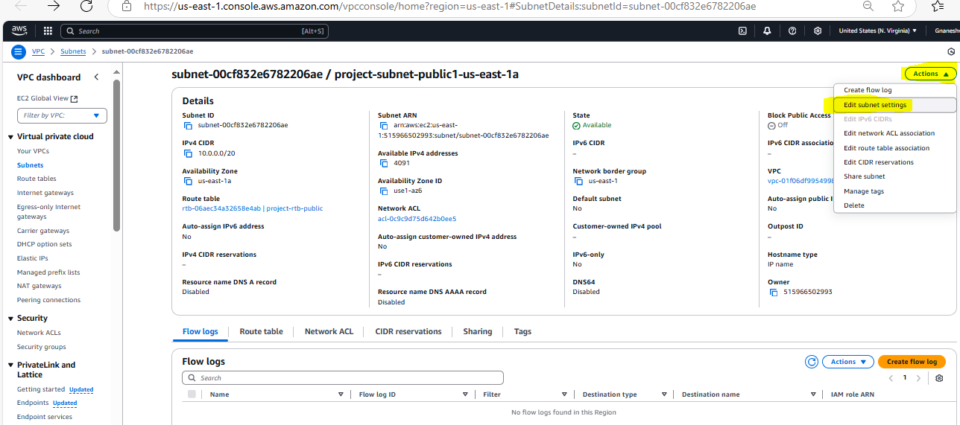

Now click on **Enable auto-assign public IPv4 address**  and save the changes

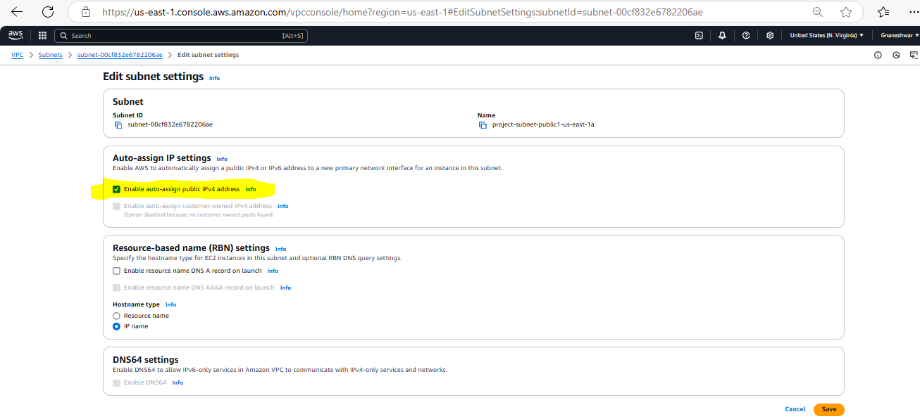

1. Add 2 private subnets in private route table

Select the **Route Table ID** which you want to add subnet and **verify by ID and project name**

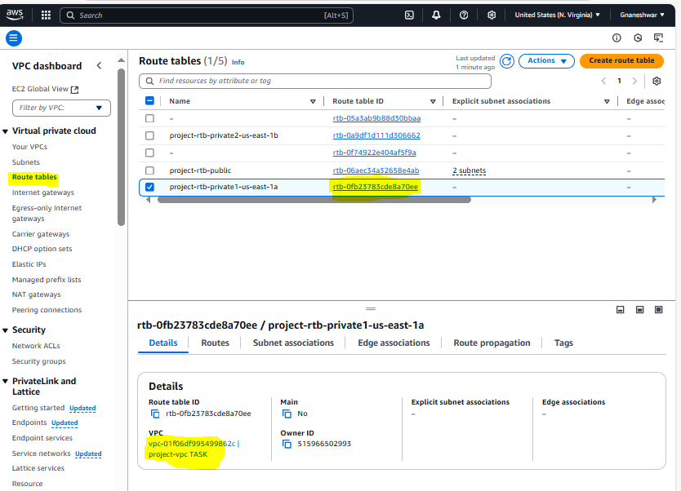

**After selecting Route table ID click on subnet Association --🡪 Edit subnet association**

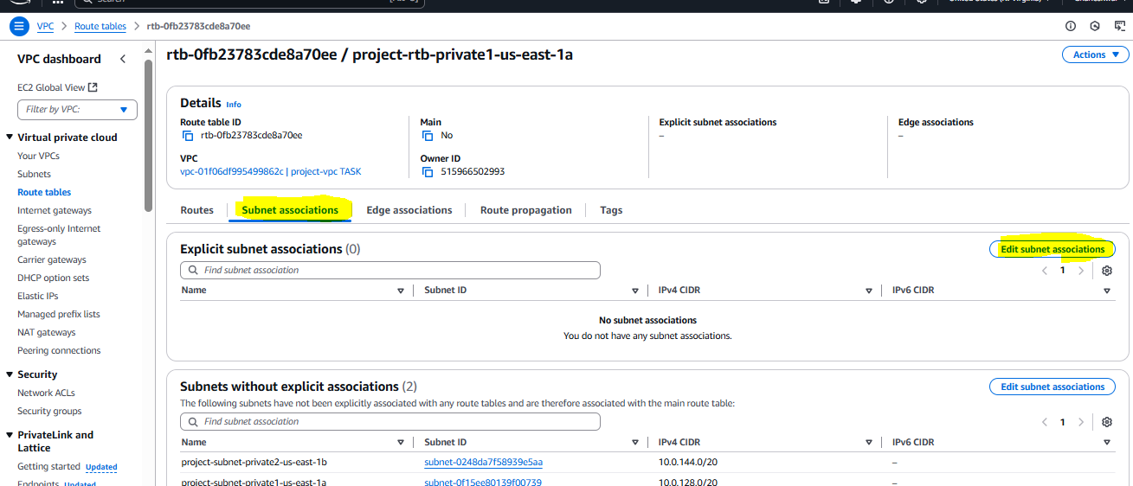

**Now select the 2 private subnet which you want to add to route table and click on save association** 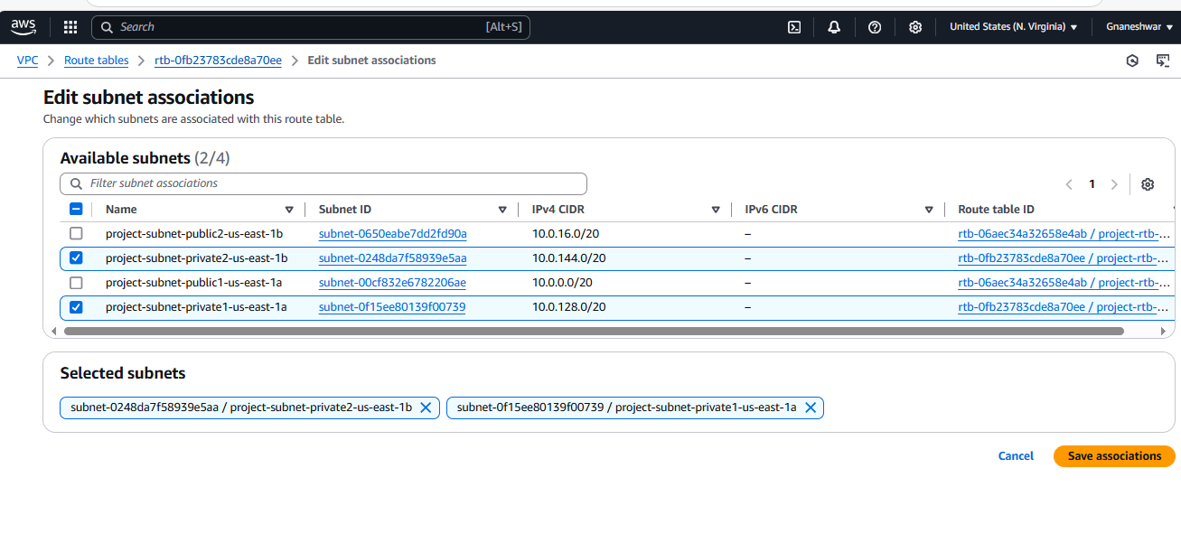

**Now you can check added subnets under subnet association of Route table**

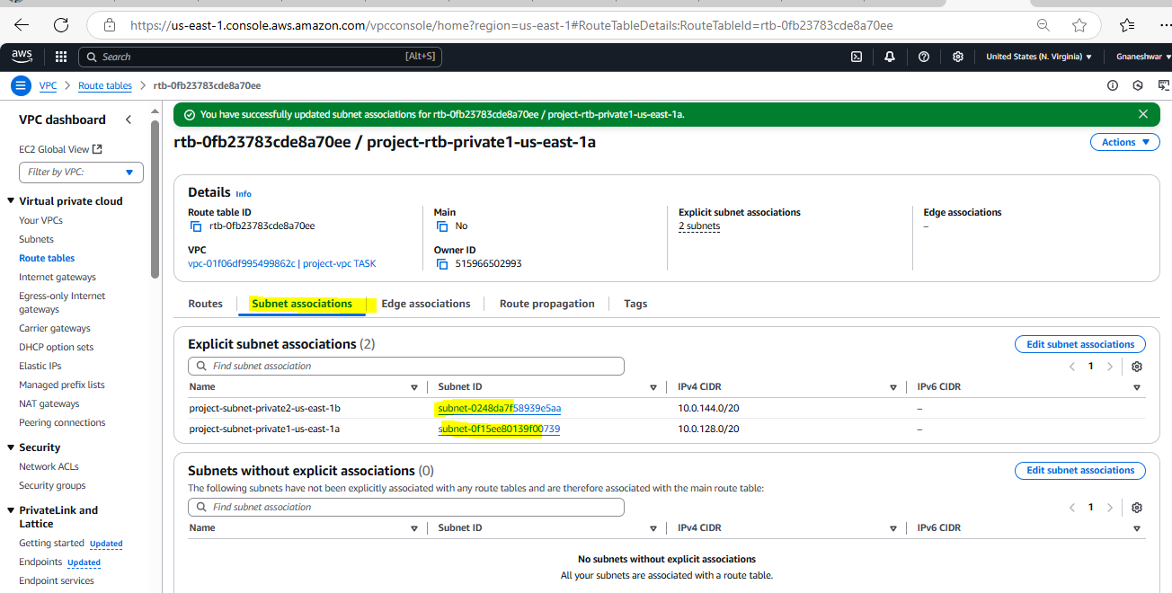

1. Add 2 public subnets in public route table

Select the **Route Table ID** which you want to add subnet and **verify by ID and project name**

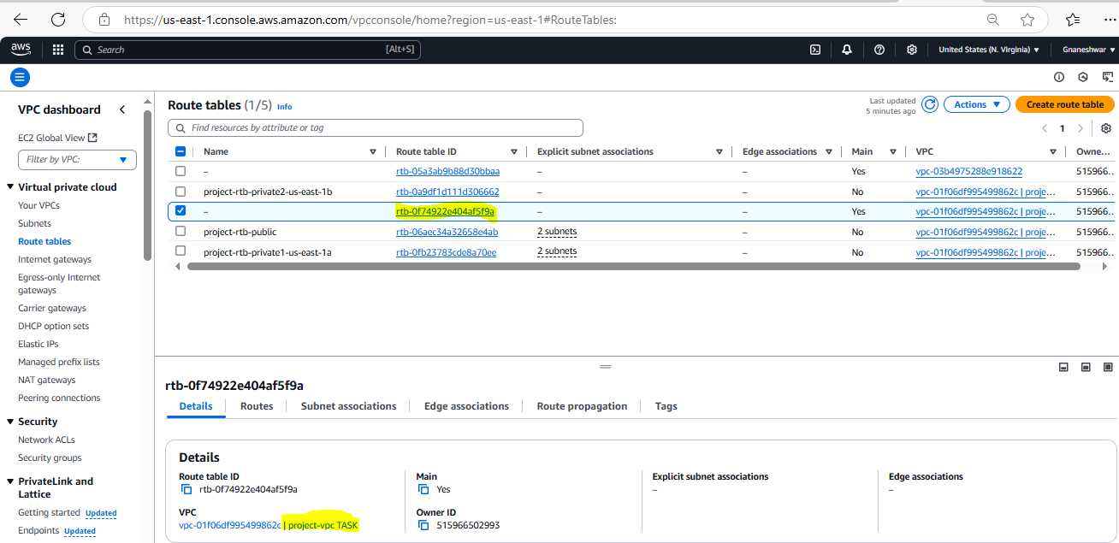

next click on select **Subnet association** --🡪 Edit subnet association

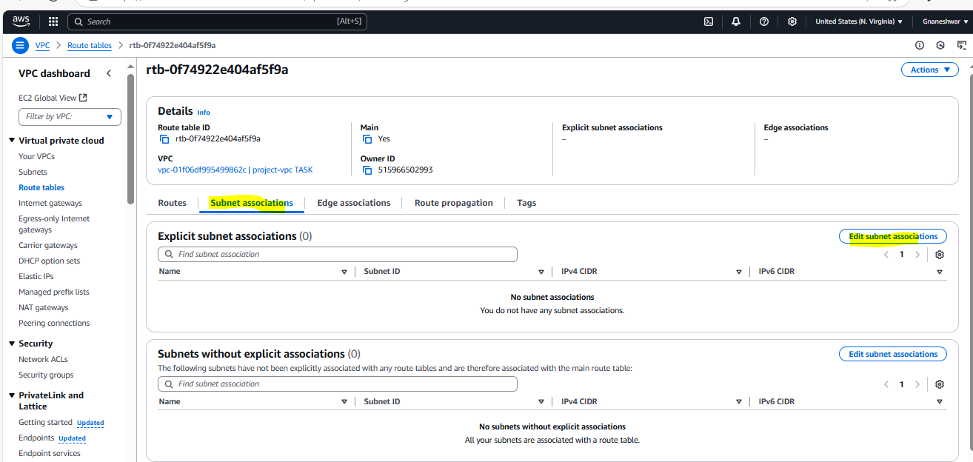

Now **select the public subnets** which you want to add to Route table click on **save Association**

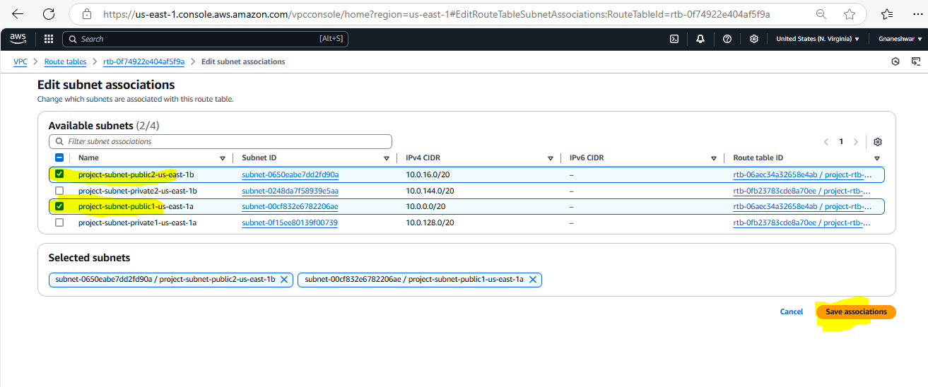 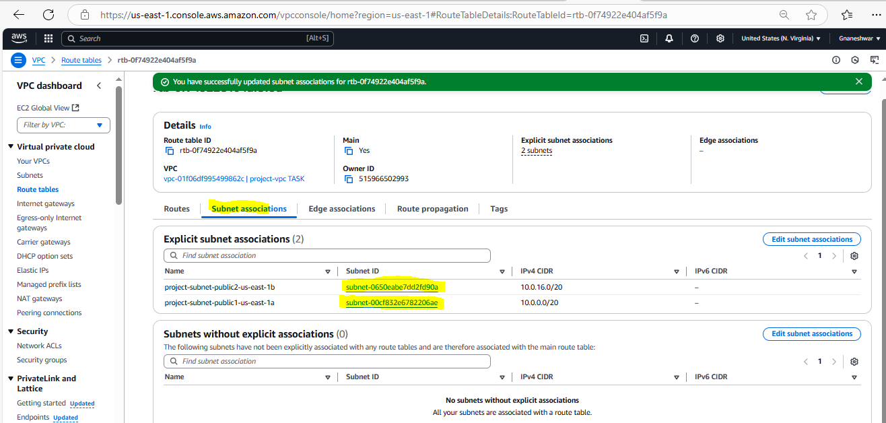

1. Public route table will have the routes to internet and local

**Select the *route table ID* in the below panel u can see *Routes***

**Click on Routes ---🡪Edit Rotes**

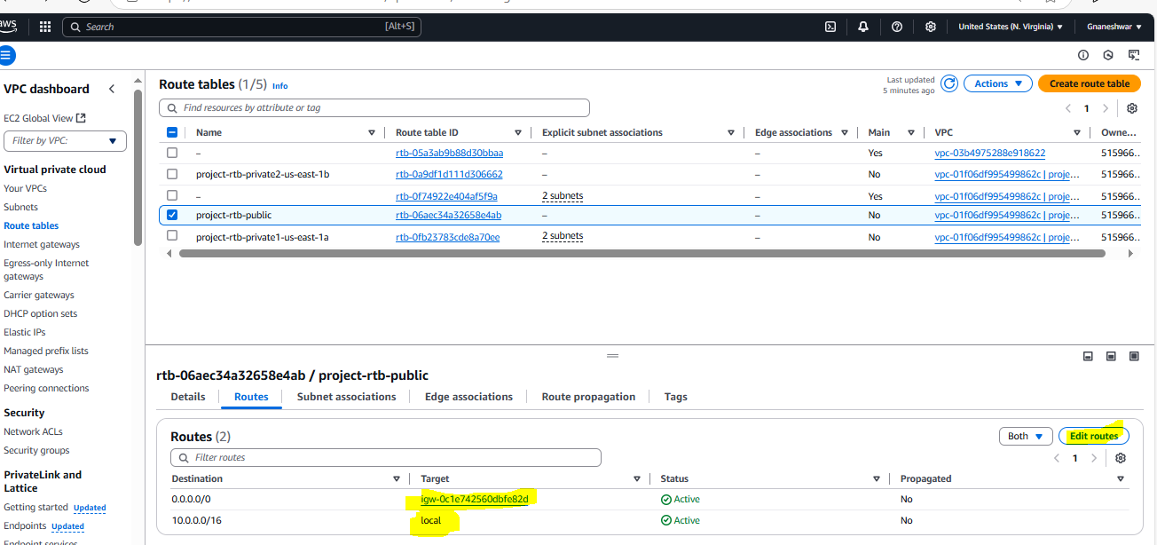

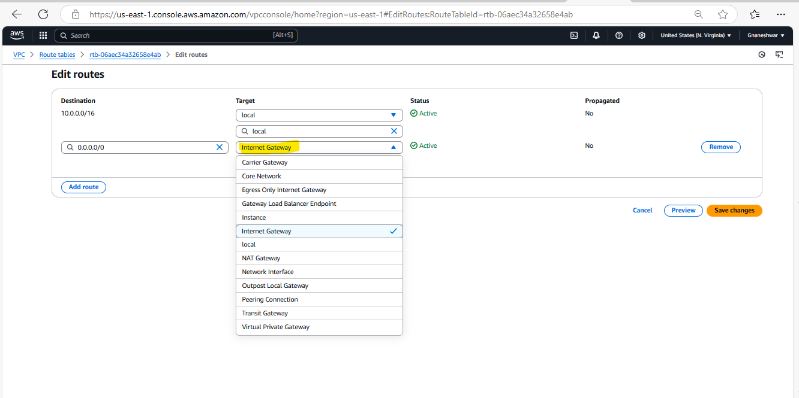

1. Create Ec2 in public subnet with t2micro and install php

**First create an instance ,in the Network settings select one public subnet**

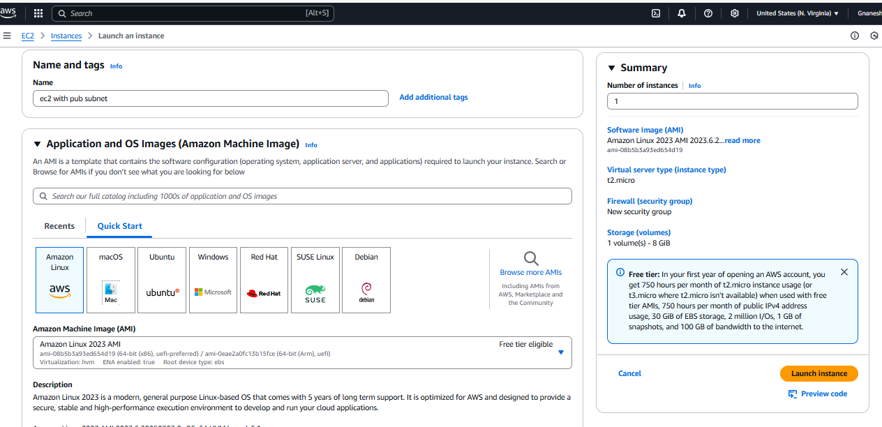

**For this I have selected the VPC and subnet which were created in the above tasks**

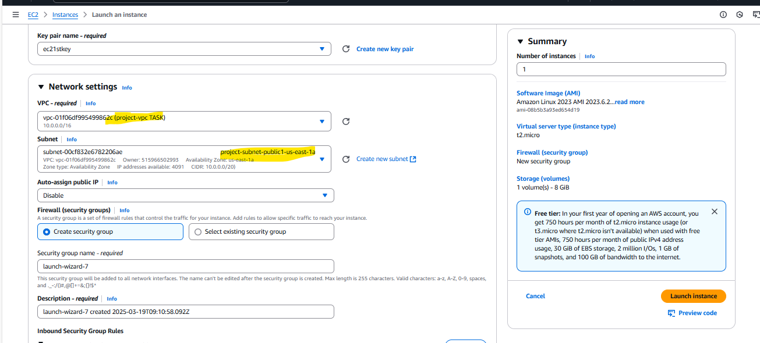

Connect to the EC2

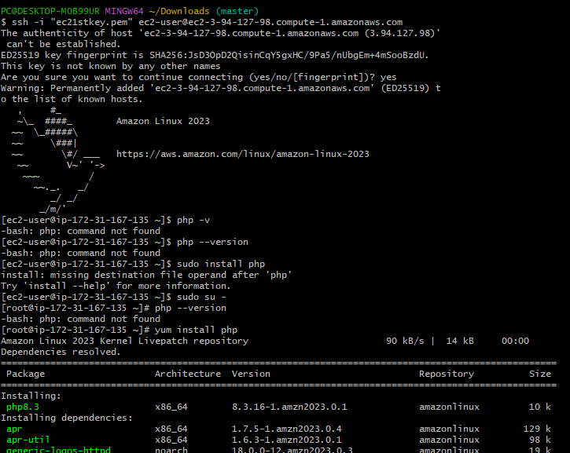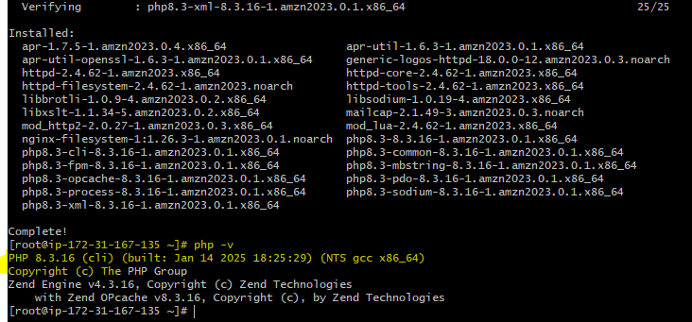

1. COnfigure Nat gateway in public subnet and connect to private Instance

**For this we have to create 2 ec2 instances, one ec2 instance with public subnet to access Internet Gateway and another ec2 instance with private subnet for which we do not need internet access**

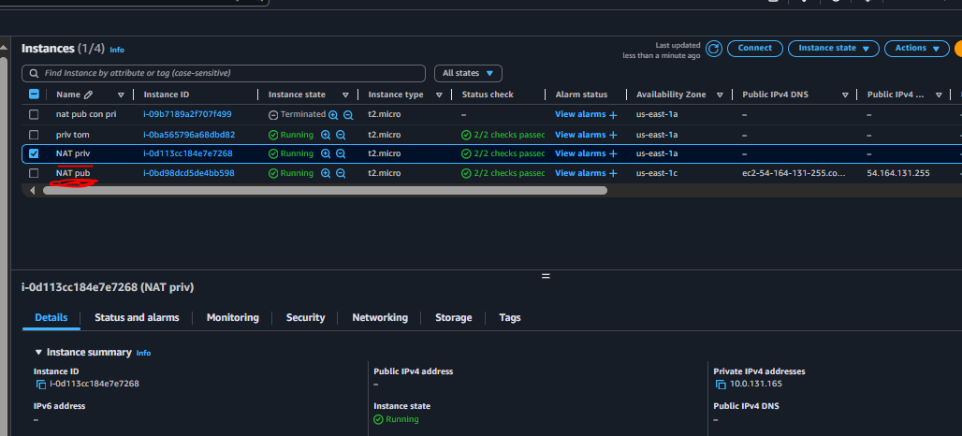

**Now Goto VPC and create one NAT gateway allocating Elastic IP in a public subnet and attach it to Private Route table**

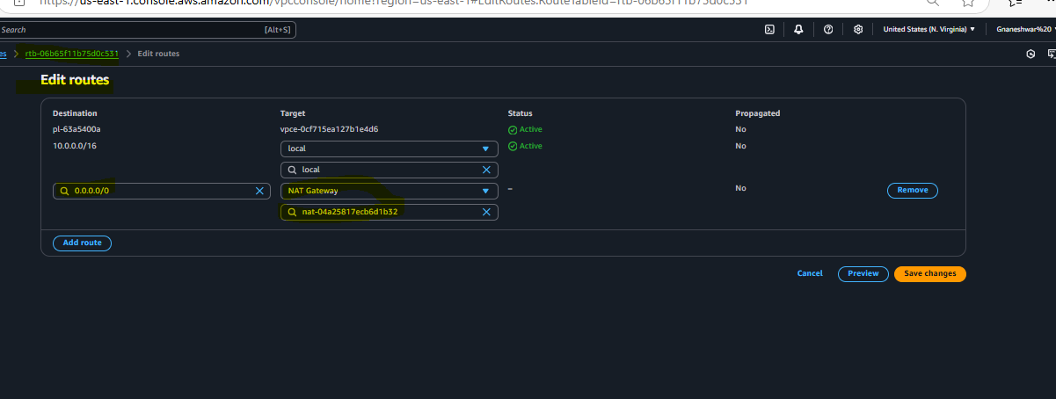

1. Install Apache Tomcat in private ec2 and deploy a sample app.

**Create an ec2 instance with VPC, while creating VPC select only private subnet**

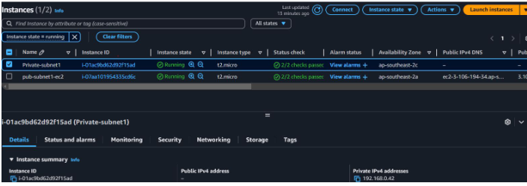

**First,go to the browser and copy link of 1 Apache tomcat tar.gz file**

**And in Git bash Change to /opt directory and download the Apache tomcat using wget command followed by link (copied)**

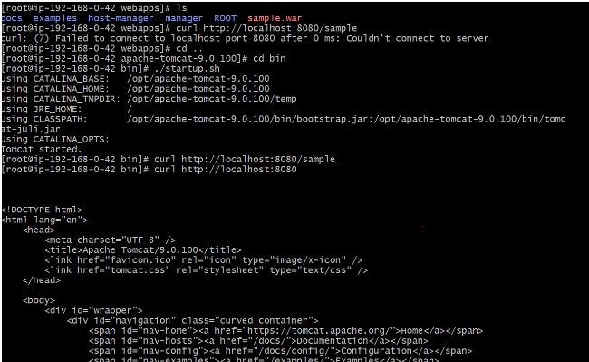

1. Configure VPC flow logs and store the logs in s3 and CloudWatch

**First select a VPC for which we need to create flowlog Now in the below panel u able see an option “FLOW LOGS” click on it for creating new flow log.**

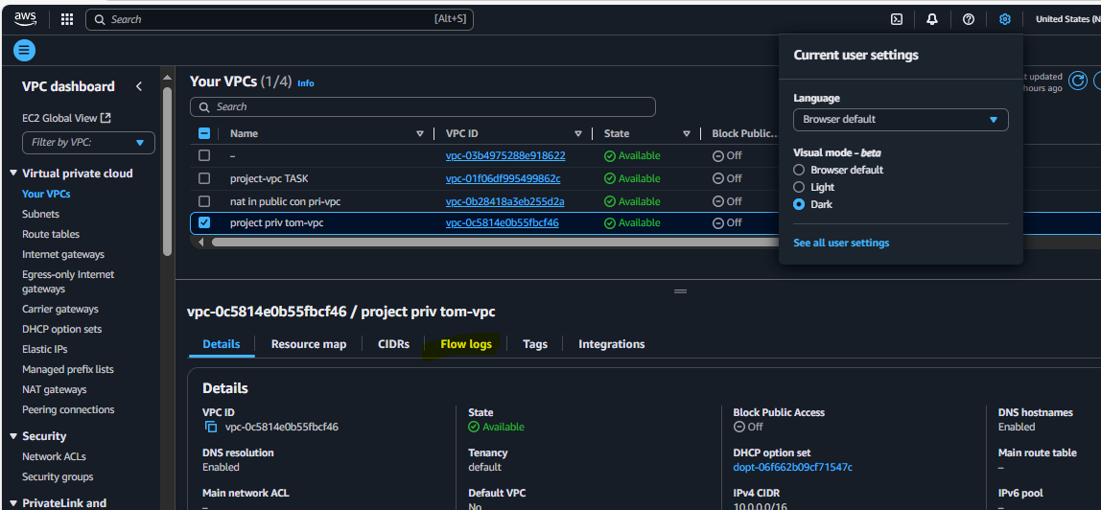 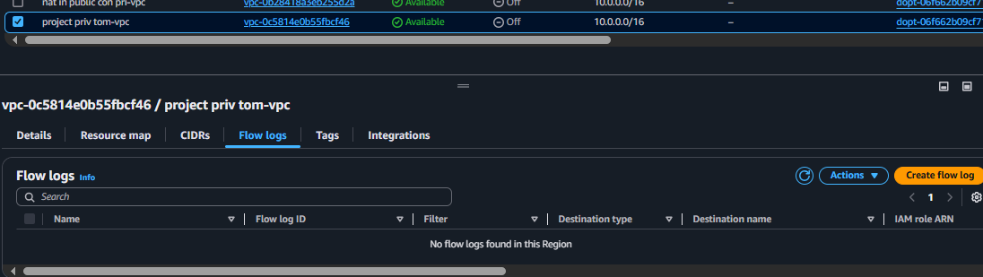

Before creatting a flow log to sa ve in S3 first,we need to create a bucket in S3 and copy it’s ARN no. to flowlog

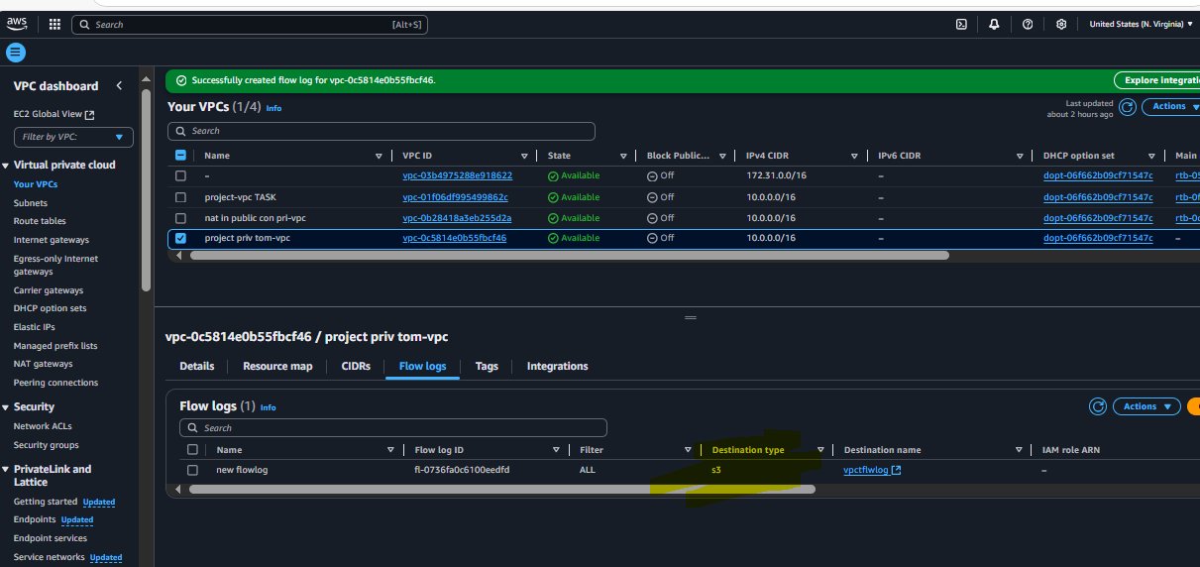

Similarly to save VPC flow logs to cloudwatch , you need existing log group or else create new log group and attach to flow logs

